* Tables can be made with in this Storage accounts 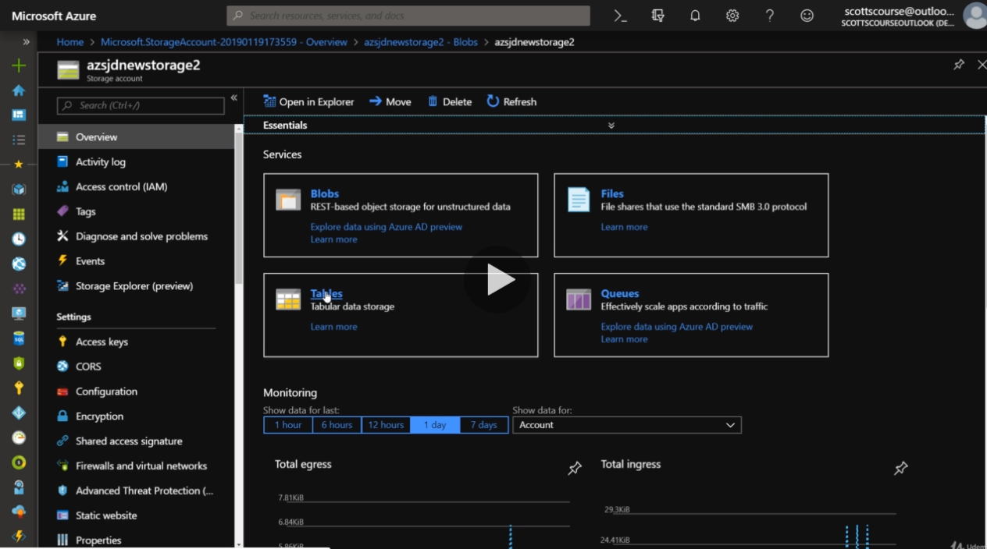
* Create a table called Employees 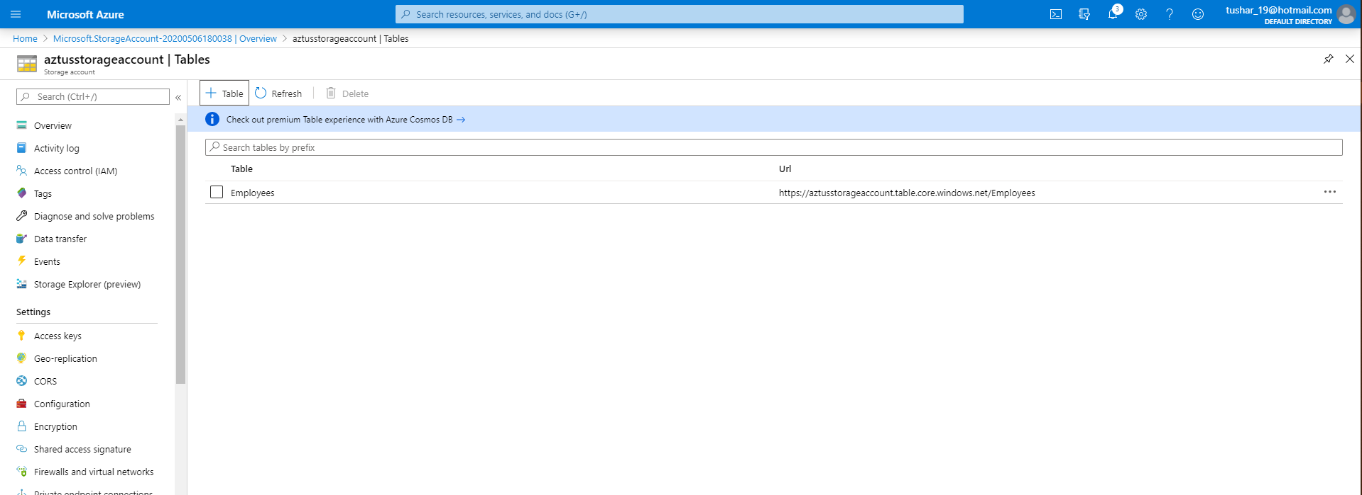
* Storage accounts are publicly accessible by default unless we tie it to a network URL and use that with in the application.
* Using the connection string and Studio you can inject data in Employee table using CloudAzureStorage account. 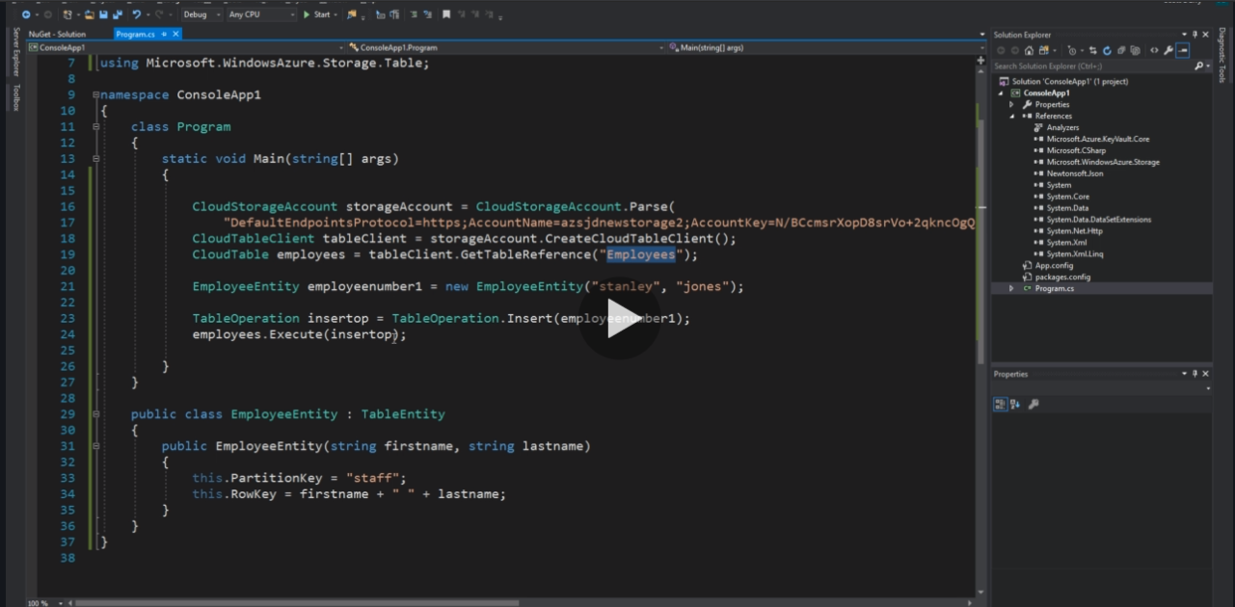
* After saving and running the program it will save in Azure Employee table.
* We can go in Storage Explorer to check if the data is there. 